| **Assignment 5** | Presentation of technical plan |
| --- | --- |
| **Group** | FieldLab 8 - Analytics of COVID trends data |
| **Members** | Milou Schamhart, Hielke Muizelaar, Christie Bavelaar, Danielle Rachman, Kenneth Fargose |

## Introduction

This report provides the technical plan to complete FieldLab 8. The final goal of the FieldLab is to provide analytics of COVID-19 in populations using media and interview data. The FieldLab has multiple elements that need to be completed within a set timeframe. Additionally, there are five team members that need to coordinate and collaborate to ensure we deliver high quality deliverables within the timelines. In order to successfully complete all elements of the FieldLab, it is key to determine a technical plan with the team.

To create this technical plan, we arranged a meeting to discuss how we should approach creating the plan. The first step we took was to define how we wanted to structure the plan. Together, we brainstormed different tools and methods that may assist us with developing a plan. Based on previous experience, we established two methods, namely, a work breakdown structure and a Gantt chart. The aim of the work breakdown structure was to provide an overview of all the elements of the FieldLab. This provides a high level overview. The Gantt chart provides a more detailed description of the tasks for each phase, the responsible team member and the timelines. This ensures that the team has a clear understanding of what needs to be done, by whom and that as a team, we are able to complete all deliverables within the required time frame.

As a group, we discussed and aligned on the elements within the work breakdown structure. Thereafter, we discussed each phase and agreed on the tasks. We worked on this together as we have different skills and perspectives within the team. By combining our different expertise and perspectives, we were able to think through each element thoroughly and ensure that all tasks were documented. Following this, we identified the responsible person for each task. We approached this in two ways. Firstly, we identified which team member had the required skills. Additionally, we discussed what skills each team member wanted to learn. We then combined a member with the skills with a member who wants to learn the skills so that we could work together and develop together. Lastly, we decided on timelines to ensure that we deliver all elements as required.

The work breakdown structure and a Gantt chart will be used as working documents so that we can track progress and work effectively together.

In the Gantt chart our timeline and production deadlines and division of tasks and responsibilities are incorporated. The Work Breakdown Structure together with the Gantt chart provides a visualisation of the steps and decision points in our project and the scope of outcome and deliverables per phase.

**Gantt chart**

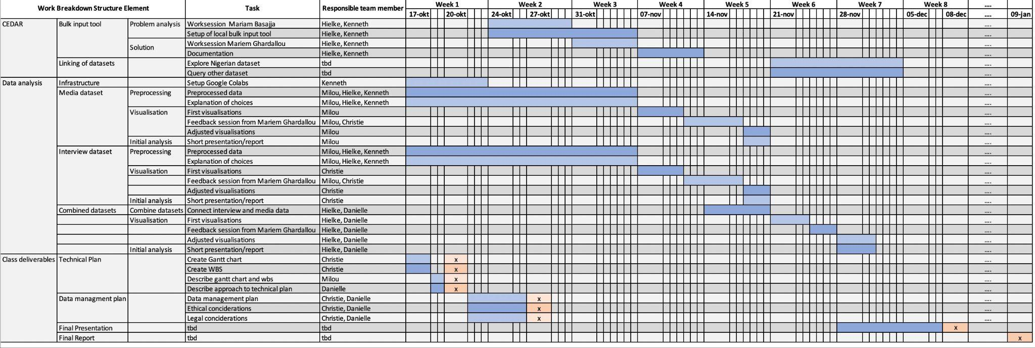

**Work Breakdown Structure**

